The 2nd announcement
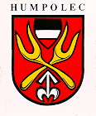
Vth International Anthropological Congress of Aleš Hrdlička
“Quo vadis homo …societas humana?“
September 2 – 5, 2009 Praha – Humpolec, Czech Republic
www.anthropology-hrdlicka2009.cz

and

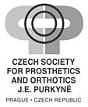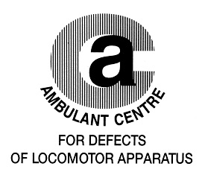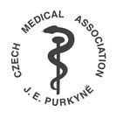

invite you for

The 11th Prague-Sydney-Lublin Symposium
Topic: Orthopaedic Anthropology

that will be held in the frame of the Vth International Anthropological Congress of Aleš Hrdlička

The Symposium is launched within the framework Bone and Joint Decade 2000 - 2010 and belongs to education actions integrated into the life training system of physicians

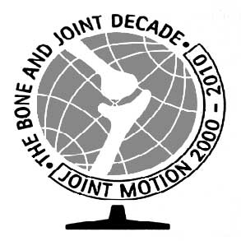

The Symposium

will be held on September 2-4, 2009
in The Medical House, Sokolská 31, 120 26 Prague 2, Czech Republic

Opening Ceremony and Welcome Party of the Vth International Anthropological Congress of Aleš Hrdlička will be held on September 2, 2009 in the Carolinum, Ovocný trh, 110 00 Prague 1 from 16.00
.
All information regarding to Registration, Abstracts – online form, Symposium fee, Accommodation, etc. you find at www. pojivo.cz

Deadline for Abstract Submission: June 15, 2009

Participants will receive abstracts of the Vth Congress of Aleš Hrdlička on CD
and the journal “Locomotor System” with programme of The Symposium and printed abstracts of lectures

Organiser: Assoc. Prof. Ivo Mařík, MD, PhD
Ambulant Centre for Defects of Locomotor Apparatus
Olšanská 7, 130 00 Praha 3
E-mail: ambul_centrum@volny.cz

