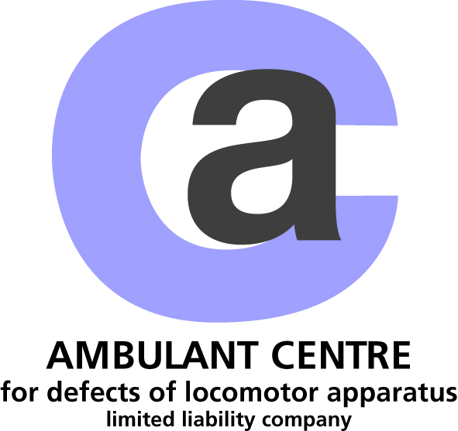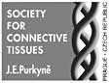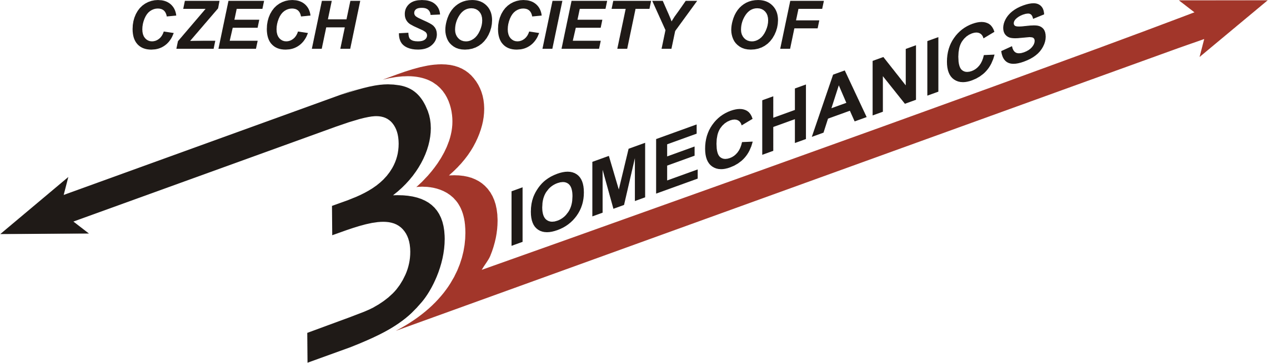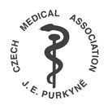

invite you for

The 13th Prague-Sydney-Lublin Symposium
Topic: Interdisciplinary Approach to Disorders of Locomotor Apparatus
&
The Workshop of the Czech Society of Biomechanics
Topic: New Trends in Biomechanics of Human Motion System: Aspects of Neuro-, Tissue and Cell Biomechanics“

The Symposium and the Workshop belong to education actions integrated into the life training system of physicians
(according to professional statute No. 16 of the Czech Medical Association)

Preliminary Programme

Friday 16, September 2011

13.30 – 14.00 registration of participants

SYMPOSIUM PROGRAMME
Marik I. Opening of the Symposium

14.00 – 17.00 chairmen: Ivo Marik, Tomasz Karski, Miloslav Kuklik

Karski T, Karski J, Kalakucki J (Lublin, Poland). The locomotor system in adulthood and senility. The insufficiency and pain in the spinal and hip regions. Is the prevention possible ? (part I) (30 min.)

Karski J, Kalakucki J, Karski T (Lublin, Poland). The Locomotor system in adulthood and senility. The insufficiency and pain in knees and feet. Is prevention possible ? (part II) (30 min.)

Toshihiko O. (Sapporo, Japan). Teratogenic mechanisms of congenital absence of digits. Presenter Marik I (Prague, Czech Republic) (40 min.)

Kuklik M, Marik I (Prague, Czech Republic). Amniotic band disruption complex (20 min.)

Marik I, Marikova A, Hudákova O, Kozlowski K (Prague, Czech Republic, Sydney, Australia). Osteolysis syndromes - destructive lesions of bone (20 min.)

Marik I, Zemkova D, Kuklik M, Myslivec R, Petrasova S, Hudakova O, Marikova A, Kozlowski K (Prague, Czech Republic, Sydney, Australia). Skeletal Dysplasias: Diagnostics. and Treatment. E-poster.

WORKSHOP PROGRAMME
Otahal S. Opening of the Workshop

17.30 – 19.00 Moderator: Stanislav Otahal
Biological complexity of human movement system – integrative biomechanics: round table discussion

Hojka V, Kubový P, Otáhal S, Bačáková R (Prague, Czech Republic). Neuromuscular differentiation in control of human take-off movements

Saturday 17, September 2011

Free Discussions - Individual Approaches I:
Complexity of Biosystems - Tissue Engineering - Nano-replacements - Histology and Nanobiomechanics - Clinical Aspects

Social Programme I

Sunday 18, September 2011
SYMPOSIUM PROGRAMME

14.00 – 17.00 chairmen: Miloslav Kuklik, Jacek Karski, Miroslav Petrtyl

Toshihiko Ogino (Sapporo, Japan). Classification of congenital hand anomalies. Presenter Marik I (Prague, Czech Republic) (40 min.)

Kuklik M, Schutz E, Krepelova A, Polachová H (Prague, Czech Republic). Basal cell naevus syndrom - new insights and opinions (20 min.)

Marik I, Smrcka V, Kuklik M, Zemkova D, Marikova A (Prague, Czech Republic).
Dysostoses with predominant involvement of limbs by Nosology and Classification of Genetic Skeletal Disorders: 2006 Revision (20 min.)

Karski J, Szponder T (Lublin, Poland). Changes in sheep´s limb axis due to elongation or shortening of the iliotibial band. Correlation to human leg axis (20 min.)

Petrasova S, Zemková D, Myslivec R, Marik I (Prague, Czech Republic). Continuous evaluation of epiphyseodesis treatment of angular deformity around the knee (20 min.)

Myslivec R, Petrasova S, Zemkova D, Marikova A, Marik I (Prague, Czech Republic). Lengthening callus strength: comparison of achondroplasia, unilateral hypoplasia and unilateral hypotrophia (growth arrest) (20 min.)

Jira A, Petrtyl M (Prague, Czech Republic). Biomechanical analyses of helical lamellas in osteons (20 min.)

WORKSHOP PROGRAMME
17.30 – 19.00 Moderator: Stanislav Otahal
Revolution in artificial organs – nanotechnology in biomechanics: round table discussion

Monday 19, September 2011

Free Discussions - Individual Approaches II:
Complexity of Biosystems - Tissue Engineering - Nano-replacements – Histology and Nanobiomechanics - Clinical Aspects

Social Programme II

Tuesday 20, September 2011
SYMPOSIUM PROGRAMME

14.00 – 17.00 chairmen: Ctibor Povysil, Tomasz Karski, Ivo Marik

Myslivec R, Klika V, Zemkova D, Marikova A, Marik I (Prague, Czech Republic). Prediction of lengthening callus strength according to biomechanical model (20 min.)

Petrtyl M, Lerach A, Lisal J, Marik I, Vitek T, Denk F (Prague, Czech Republic). Electronically regulated lengthening of diaphyses in children (20 min.)

Petrtyl M, Lisal J, Danesová J (Prague, Czech Republic). Properties and behaviour of synthetic synovial fluid (30 min.)

Lisal J, Petrtyl M, Senolt L, Danesová J (Prague, Czech Republic). Properties and behaviour of pathological synovial fluid in patients with osteoarthritis and rheumatic arthritis
(20 min.)

Povysil C, Podskubka A, Handl M (Prague, Czech Republic). Comparison of the results of autologous chondrocytes transplantation with two different scaffolds (30 min.)

Lerach A, Sibr M, Bodlak D, Drab F, Denk F, Paska J, Jirak P, Kocum P (Prague, Czech Republic). The Bilateral Individual Replacement of Ramus Mandibulae and Temporomandibular joint (10 min)

Marikova H, Eckschlager T, Hrabeta J, Cipro S (Prague, Czech Republic). Transcription factor HIF-1α as a cancer drug target (20 min.)

WORKSHOP PROGRAMME
17.30 – 19.00 Moderator: Karel Jelen
Problem of biomechanical interpretation of hypokinetic stress: round table discussion

Marik I. Otahal S. Assessment and conclusion of the Symposium & the Workshop

Note: Lectures and text slides will be presented in English,
time of the individual lectures can be changed

The Symposium and the Workshop
will be held on 15th – 22nd September 2011
at MEROPI (Faliraki) on RHODOS, GREECE (8 km southwards from the main city Rhodos, on the eastern seaside)

Conference fee 10 Euros will be paid during registration
Participants will receive the journal Locomotor System 3+4/2011 with programme and abstracts of lectures and Certificate of Attendance

Associate Professor Ivo Marik, MD, PhD, FABI
Chief of the Centre for patients with Locomotor Defects, Prague, CZ
President of the Society for Connective Tissue Czech Medical
Association J.E. Purkyne (www.pojivo.cz)
Olšanská 7, 130 00 Prague 3, Czech Republic
Tel. +420 222 582 214
E-mail: ambul_centrum@volny.cz

&

PhDr. Marta Hrušková
Research department of Faculty of Physical Education and Sport, Charles University in Prague
tel.: + 420 220 172 004; mobil: +420 603 262 426; fax: +420 242 454 706
E-mail: hruskova@ftvs.cuni.cz

