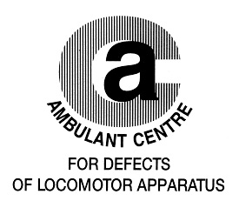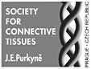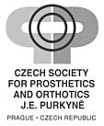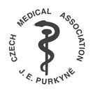

invite you for

„Conference on Hand Anomalies“
with guest of honour Professor Toshihiko Ogino, MD, PhD
Chairman of Department of Orhopaedic Surgery Yamagata University School of Medicine, Yamagata, Japan

The conference belongs to education actions integrated into the life training system of physicians (according to professional statute No. 16 of the Czech Medical Association)

P r o g r a m m e
16.45 registration of participants

17.00 – 18.15 chairmen: I. Marik, J. Hyanek

Marik I. Opening

Toshihiko Ogino (Yamagata University School of Medicine, Japan). Teratogenic mechanisms of congenital absence of digits

Toshihiko Ogino (Yamagata University School of Medicine, Japan). Classification of congenital hand anomalies

COFFEE BREAK

18.30 – 20.00 chairmen: V. Smrcka, M. Kuklik

Vaclav Smrcka,Vítezslav Kuzelka, Ctibor Povysil (Institute for History of Medicine and Foreign Languages, 1st Faculty of Medicine, Charles University, Prague). Congenital bone anomalies and varieties of upper and lower extremities

Pavel Kurial (Department Plastic Surgery, Hospital Ceske Budějovice,CZ). Digital free flap-salvage procedure

Ivo Marik, Vaclav Smrcka, Miloslav Kuklik, Daniela Zemkova (Ambulant Centre Locomotor Defects, Prague, CZ). Dysostoses with predominant involvement of limbs by Nosology and Classification of Genetic Skeletal Disorders: 2006 Revision

The Conference

will be held on 14th April 2011 from 17.00
at The Domus medica, Sokolská 31, 120 26 Prague 2, Czech Republic

Participants will receive Certificate of Attendance

Organiser: Assoc. Prof. Ivo Marik, MD, PhD
Ambulant Centre for Defects of Locomotor Apparatus
Olšanská 7, 130 00 Praha 3, CZECH REPUBLIC
Tel.: +420 222 582 214
E-mail: ambul_centrum@volny.cz

